**Include Special Remarks**

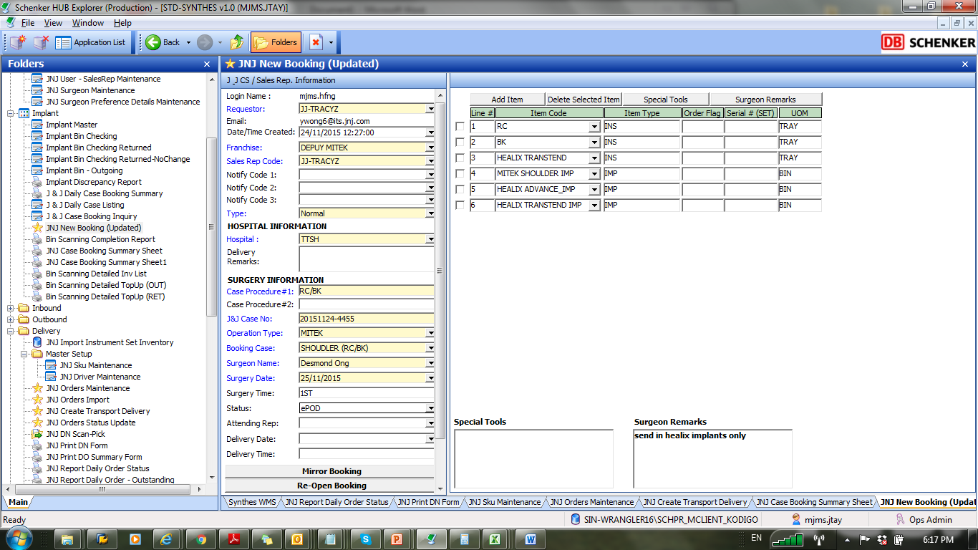To include special remarks in the **JNJ Case Booking Summary Sheet:**

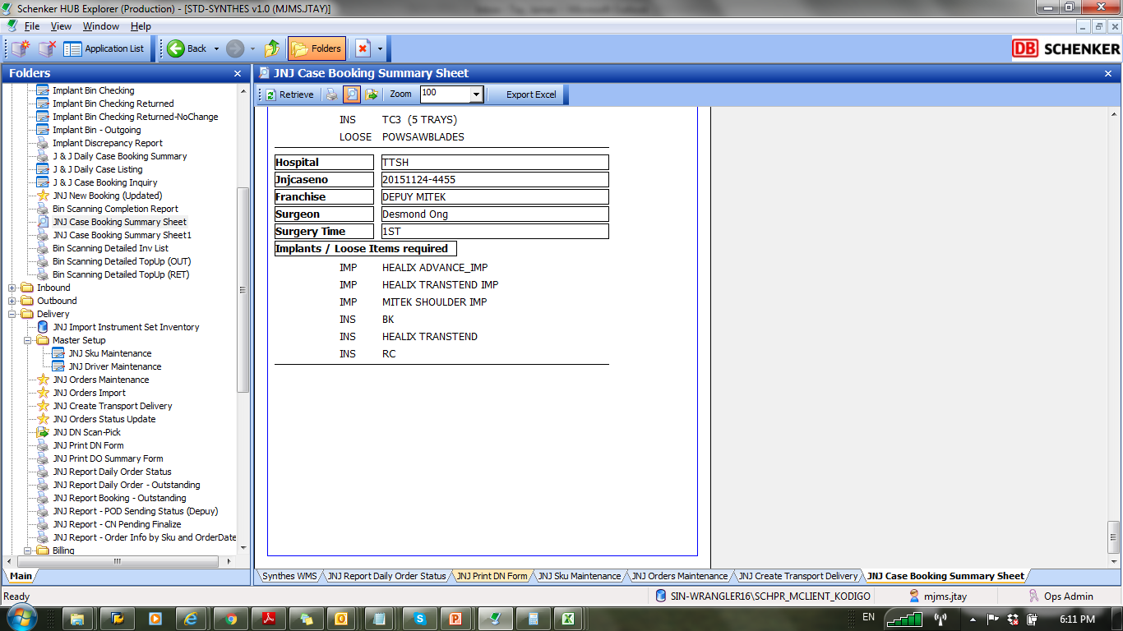

***To populate special remarks & surgeon remarks in this report as well***